THE BARAZA FRAMEWORK.
XML MODULE DOCUMENTATION.

The Baraza framework makes use of XML to define its components. The XML file is contained in the configs directory. The XML file contains all the variable names, methods names and properties names along with additional information about the system which store and send information.

A sample XML file is shown below.

<?xml version="1.0"?>

<addressbook>

<person>
<name>simon</name>
<email>simon at Dewcis.com</email>
</person>

<person>
<name>Denis</name>
<email>Denis at Dewcis.com</email>
</person>
</addressbook>

HOW THE XML MODULE WORKS.

The XML is first converted into a XML document object in memory using the XML parser. The XML object contains a tree of nodes that contains the data and structure of the information contained in the XML document. These tree of nodes can be accessed and modified using the DOM API
The general design of the application is thus defined in the XML file. The figure below illustrates the XML parser and the DOM layer.

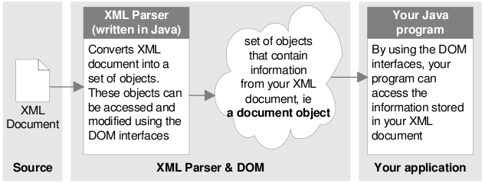

Fig. The XML parser and the DOM layer.

The main node in the application is the root node, otherwise referred to as the document. Once a document object tree has been created, you can access the elements in that tree and you can also modify, delete and create leaves and branches by using the interfaces in the API.

The baraza framework uses XML to define many of the application components, including the user interface, database and the application's reports.

The figure below shows how information in an XML document can be represented as a tree of nodes.

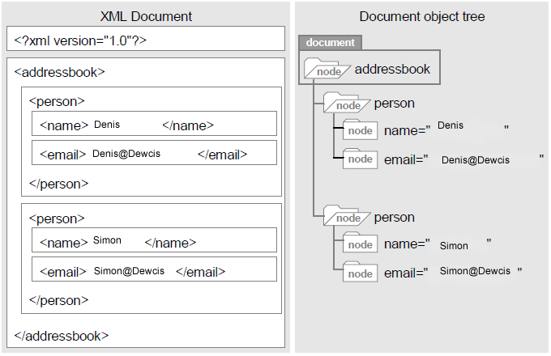
This XML document can be used to create a GUI with the two labels(name and email) and two text-box fields where a user is expected to enter the relevant details, which will be reflected back to the database.

Definition of terms.

elements :are the basic building blocks of XML. They have children that are other elements, text nodes or a combination of both. Are the only nodes that can have attributes.

document :is the overall parent for all the other nodes in the document.

Dom Api : defines a set of minimal (language and platform independent) interfaces for accessing and manipulating the structure of information stored in XML documents, in a hierarchical manner.

Discussion.

The document object model(DOM) is the foundation of Extensible Markup Language. XML documents have a hierarchy of informational units called nodes. DOM is a way of describing those nodes and the relationships between them.

The DElement.java and DXML.java documentation.
The DElement and DXML classes are the building blocks of the baraza framework XML.
1). DXML.java.

The Document object is an interface, so it can't be instantiated directly. The application uses a factory instead. Parsing the file is a three step process.

a) Create the DocumentBuilderFactory. This object will create the DocumentBuilder.
b) Create the DocumentBuilder. The DocumentBuilder will do the actual parsing to create the Document object.
c) Parse the file to create the Document object.

this is implemented as shown in the code block below (baraza.java file found in the source folder under the XML directory).

package org.baraza.xml;

import javax.xml.parsers.DocumentBuilder;
import javax.xml.parsers.DocumentBuilderFactory;
import javax.xml.parsers.FactoryConfigurationError;
import javax.xml.parsers.ParserConfigurationException;

import org.xml.sax.SAXException;
import org.xml.sax.SAXParseException;

import java.io.ByteArrayInputStream;
import java.io.InputStream;
import java.io.IOException;

import org.w3c.dom.Document;
import org.w3c.dom.DOMException;

public class DXML {
private DElement root;

public DXML(String xml, boolean isText) {
try {
// initialize Specifications from a Local Property file
DocumentBuilderFactory factory = DocumentBuilderFactory.newInstance();
DocumentBuilder builder = factory.newDocumentBuilder();
Document document = null;
if(isText) {
InputStream in = new ByteArrayInputStream(xml.getBytes("UTF-8"));
document = builder.parse(in);
} else document = builder.parse(xml);
root = new DElement(document);
} catch (SAXParseException ex) {
System.out.println("XML Error : " + ex.getMessage());
} catch (ParserConfigurationException ex) {
System.out.println("File IO error : " + ex);
} catch (SAXException ex) {
System.out.println("File IO error : " + ex);
} catch (IOException ex) {
System.out.println("File IO error : " + ex);
} catch(Exception ex) {
System.out.println("File Creation error");
}
}

public DElement getRoot() {
return root;
}
}

First, java imports the necessary classes. With all the different posibilities in creating a parser, there are many things that can go wrong. With the catch blocks, you can catch specific exceptions related to the varios aspects of creating and using a parser.

2)DElement.java
Once the application determines the root element, it retrieves a list of the root element's children as a Nodelist. The NodeList class is a series of items that the application can iterate through. In Delement.java its described as:

-necessary packages imported.

import org.w3c.dom.Node;
import org.w3c.dom.NodeList;
import org.w3c.dom.NamedNodeMap;

code:
.....
elements = new ArrayList<DElement>();
NodeList elementlist = node.getChildNodes();

.......

It iterates through the child nodes to see if they have siblings, and further checks the value of the siblings if any which it outputs.
The code segment below, also from DElement.java shows this.

....

for (int i=0; i < elementlist.getLength(); i++) {
if(elementlist.item(i).getNodeType()!=3)elements.add(new DElement(elementlist.item(i)));
else {
if(elementlist.item(i).getNodeValue()!=null)
value += elementlist.item(i).getNodeValue().trim();
}

......

